**(28-09-2022) C++ PROGRAMS**

PROGRAM – 1:

*C ++ Program to print the student details using constructor*.

#include<iostream>

#include<string.h>

using namespace std;

class student

{

private:

int no;

char name[20];

public:

student()

{

cout<<"Enter the value of name = ";

cin>>name;

cout<<"Enter the reg no = ";

cin>>no;

}

void display()

{

cout<<"\n\n";

cout<<"STUDENT DETAIL";

cout<<"\n\n";

cout<<"Student name is "<<name;

cout<<"\nRegis number = "<<no;

}

};

int main()

{

student s;

s.display();

return 0;

}

**OUTPUT:**

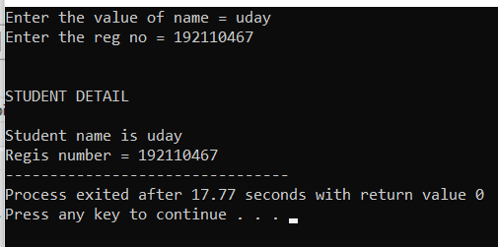

PROGRAM – 2:

*C++ Program to print the name of the student by creating class, number and name is pass while creating a object, the name should be unknown otherwise the name should be equal to the string value while creating the object of the student class.*

#include<iostream>

using namespace std;

class student

{

int no;

char *name;

public:

student();

student(int,char*);

void disp();

};

student::student()

{

}

student::student(int x,char* y)

{

no=x;

name=y;

}

void student::disp()

{

cout<<"NO = "<<no;

cout<<"\nName = "<<name;

}

int main()

{

student s(467,"udaykumar");

s.disp();

}

**OUTPUT:**

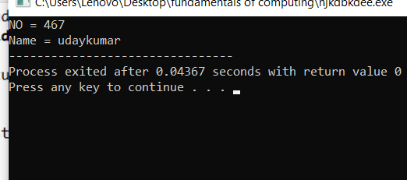

PROGRAM – 3:

*Create a class name Rectangle with two data member length and breadth and the function to calculate Area o rectangle this contain three having no parameter, having two parameter, and another function contains one parameters.*

#include<iostream>

using namespace std;

class rectangle

{

public:

int l,b,a;

rectangle()

{

}

rectangle(int x,int y)

{

l=x;

b=y;

}

rectangle(int z)

{

z=l*b;

}

void cal()

{

a=l*b;

cout<<"The Area of the Given value = "<<a;

}

};

int main()

{

rectangle r(7,7);

r.cal();

return 0;

}

**OUTPUT:**

**Area of the Given value:**49

PROGRAM – 4:

*Write a C++ program to create a class add amount data members amount initial value of 50,two constructor without parameter i.e, no amount and the second function contains parameter amount will be added in your account . create an object and display the final amount.*

#include<iostream>

using namespace std;

class addamount

{

public:

int a,b,c;

addamount()

{

}

addamount(int x)

{

b=x;

}

void display()

{

a=700;

c=a+b;

cout<<"The Total amount = "<<c;

}

};

int main()

{

addamount b(800);

b.display();

}

**OUTPUT:**

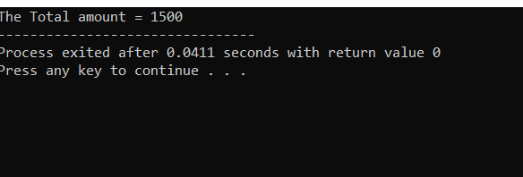

PROGRAM -5:

*Create a class print number to print various no of different data types like creating different functions with same name printn having a parameters for each data types.*

#include<iostream>

using namespace std;

class printnumber

{

int a;

float b;

char c;

double d;

long e;

bool f;

public:

void printn(int x)

{

a=x;

}

void printn(float y)

{

b=y;

}

void printn(char z)

{

c=z;

}

void printn(double p)

{

d=p;

}

void printn(long q)

{

e=q;

}

void printn(bool r)

{

f=r;

}

void num()

{

cout<<"Integer = "<<a;

cout<<"\nCharacter = "<<c;

}

};

int main()

{

printnumber u;

u.printn(70);

u.printn('K');

u.num();

}

**OUTPUT:**

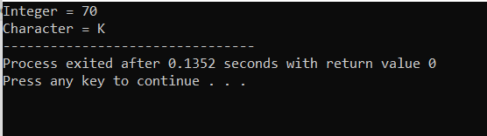

PROGRAM – 6:

*Create a class to print an integer and character using two function having same name by different sequence of integer and character.*

#include<iostream>

using namespace std;

class operate

{

int a;

char b;

public:

void print(int x, char y)

{

a=x;

b=y;

}

void print(char z,int w)

{

a=w;

b=z;

}

void display()

{

cout<<"number = "<<a;

cout<<"\nname = "<<b;

}

void display1()

{

cout<<"\nname = "<<b;

cout<<"\nnumber = "<<a;

}

};

int main()

{

operate o;

o.print(1,'X');

operate o1;

o1.print('X',1);

o.display();

o1.display1();

}

**OUTPUT:**

